‘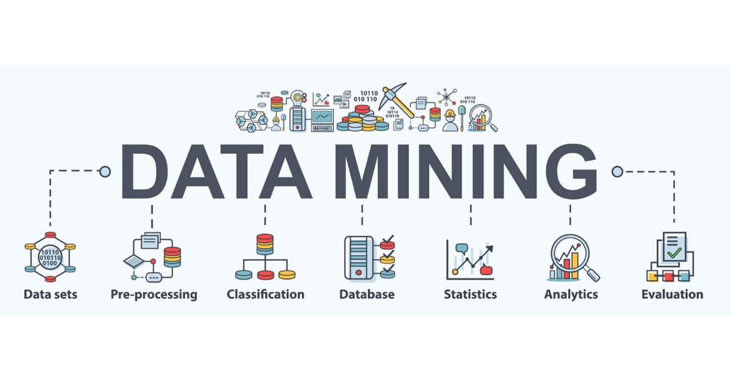

Group Assignment – Clustering
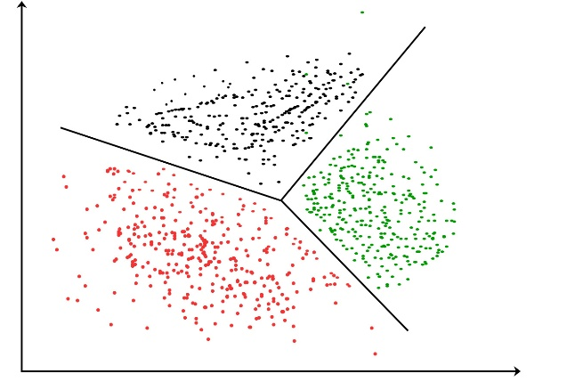

Anadi Ranjan

Business Problem
The company struggles with assigning mentees to suitable mentors due to an unstructured process that overlooks key factors like skills, learning styles, and development goals. This results in poor mentor-mentee alignment, low engagement, and underutilization of internal talent. The goal is to ensure compatibility between mentors and mentees, enhance the mentoring experience, and support employee growth


Business Objective
The objective is to improve the effectiveness of the company’s mentorship program by aligning mentees with mentors who best match their competencies and learning preferences. This alignment aims to enhance engagement, foster meaningful mentor-mentee relationships, and support overall employee development and create a final report where mentees have been assigned to which mentors.



Business Constraints
- The mentor should be one notch higher in designation than the mentees. Only map RM5 to RM4.
- Each mentor can have maximum of 5 - 7 mentees
- The mentees weak in certain competencies should be mapped to the mentors being strong in those competencies
- While mapping the mentors and the mentees try matching their learning styles too

Analysis
Variables
- Competency (Continuous Variable)
- Learning style (Continuous variable)

Strategy and Observation
The strategy involves combining both mentor (RM5) and mentee (RM4) data into a single dataset and performing standardization on their competency scores and learning style preferences to ensure comparability. K-means clustering was applied to this standardized data, and based on analysis, the optimal number of clusters was found to be three.

Upon examining the cluster centroids, it was observed that:
- Cluster 1 exhibits the highest average values in terms of both competencies and learning styles, indicating strong potential mentors.
- Cluster 2 represents intermediate averages and is considered moderately strong.
- Cluster 3 shows the lowest averages and includes mentees with lower competency and weaker learning style alignment.

Based on this insight, the following mapping approach is used:
- Mentors from Cluster 3 are excluded from the assignment process due to their low competency and learning style scores.
- Mentees from Cluster 3 are assigned to mentors from Cluster 1 or Cluster 2, prioritizing learning style compatibility.
- Mentees from Cluster 2 are mapped to mentors primarily from Cluster 1, and selectively from Cluster 2, again based on learning style alignment.
- Mentees from Cluster 1 are assigned mentors from the same cluster, as they are closely matched in both competencies and learning preferences.

Centroid Table
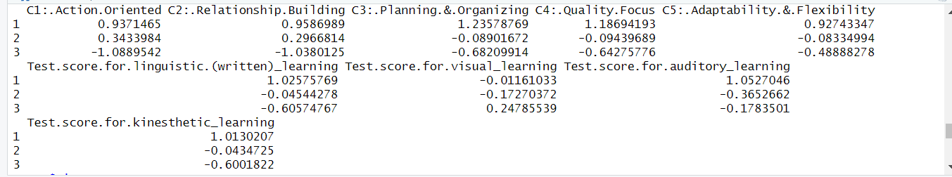

Cluster Size
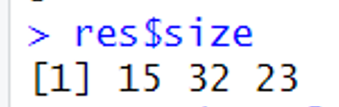

EXCEL

Final mapping of the Mentor and Mentee

Mentor - Employee ID | Designation | Mentee – Employee ID
1 | RM5 | 40,47
2 | RM5 | 33,60
3 | RM5 | 27,29
7 | RM5 | 53,41
8 | RM5 | 59,65
9 | RM5 | 31,34,55,58
10 | RM5 | 35,36,43,44,46
13 | RM5 | 52,61
15 | RM5 | 54
17 | RM5 | 30,32
18 | RM5 | 49,50,51
19 | RM5 | 42,45,69,48,63
20 | RM5 | 39,62
21 | RM5 | 26,28
23 | RM5 | 38,67,68,70
24 | RM5 | 64,66
25 | RM5 | 37,57


# THANK YOU #

